# Group 2 Team 1 Personas

**Professor**

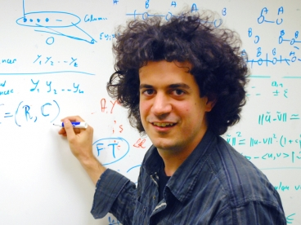

* Successful career in business and academia.
* Has led many successful global projects.
* Significant expertise in development methodologies, including agile and waterfall approaches.
* Wants to help students achieve success through classroom interactions.

**Facilitator**

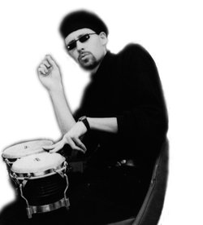

* Works a full-time job in addition to facilitating on-line classes with BU metropolitan college.
* 40 years old with a background in software development.
* Is an expert with scrum and distributed development practices.
* Has facilitated many classes online before.

**Site Administrator**



* 45 years old, married and has 3 kids.
* Is responsible for tier 2 help desk tickets, and escalates when necessary.
* Does not like to add anything new to the production instance of a server, leading him to scrutinize tickets that cross his desk.
* Worries that anything that goes outside the firewall will cause a security issue.
* Passionate about Linux.

**Student**



* 23 years old and works as a junior quality engineer for a niche software company headquartered in Modesto.
* Is a diligent student, working to ensure that her future is independently secure and can climb the professional ladder.
* Has a degree in CS from Cal State-Fresno.
* Enjoys going downstairs for coffee in new urbanism-inspired apartment building that she lives in with best friends from college.

**Guest**



* Wants to understand more about distributed development term projects for CS633.
* 27 years old.
* Likes to surf the web on generic, non-branded PC equipment.
* Easily impressed with basic website features.